# INTRODUCTION

* 1. **Overview**
  2. Event management is the process of creating and maintaining an event. This process spans from the very beginning of planning all the way to post-event strategizing.
  3. **Description**
  4. The project aim is to provide real-time knowledge for all the students who have basic knowledge of Salesforce and Looking for a real-time project. This project will also help to those professionals who are in cross-technology and wanted to switch to Salesforce with the help of this project they will gain knowledge and can include into their resume as well.

1. **Problem Definition & Design Thinking**
2. **Empathy Map**
   1. 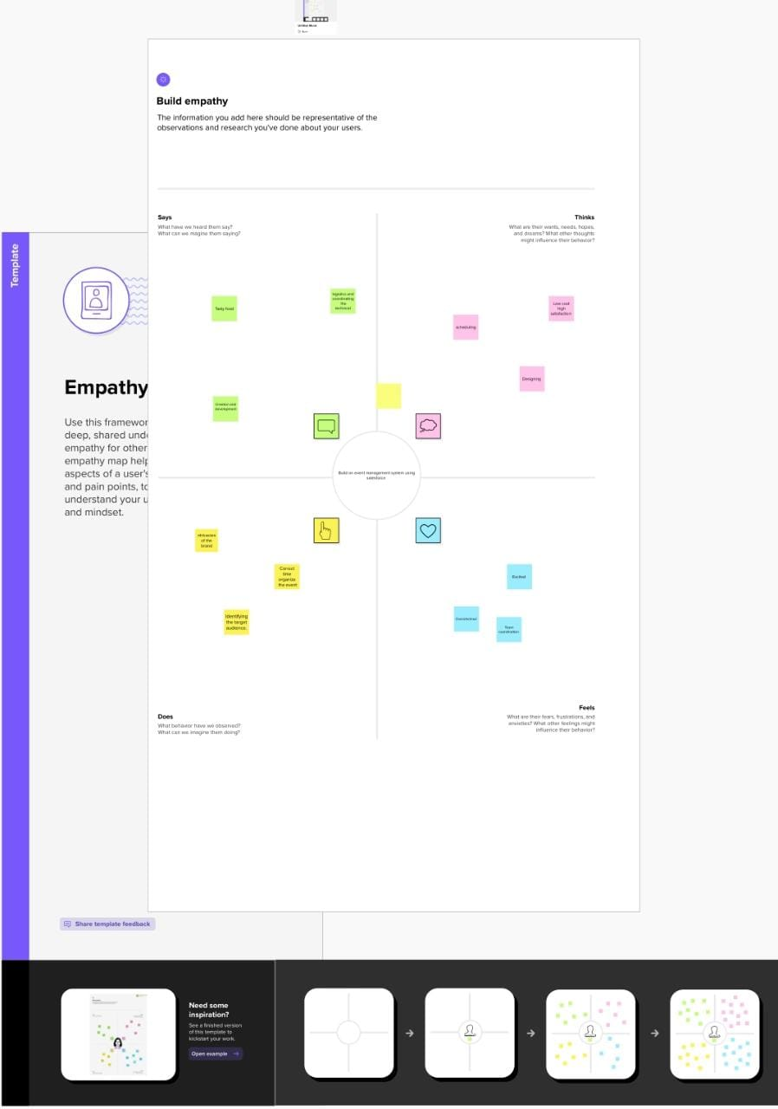
   2. **2.2 Ideation & Brainstorming Map**
   3. 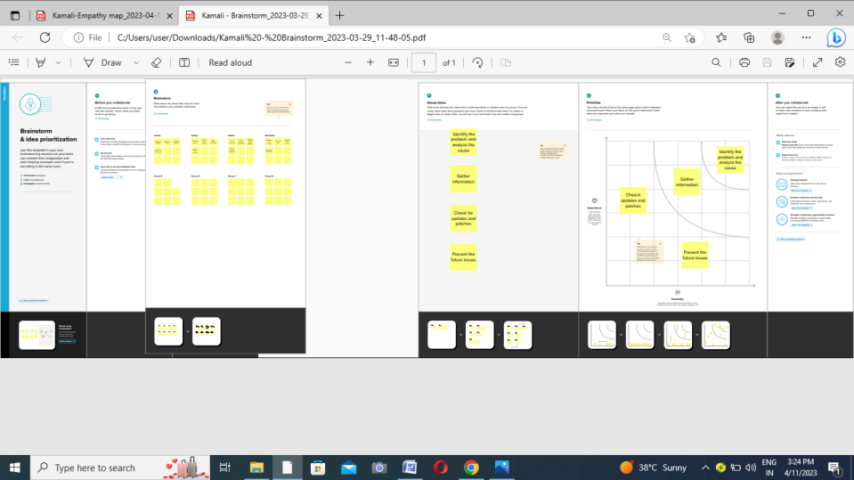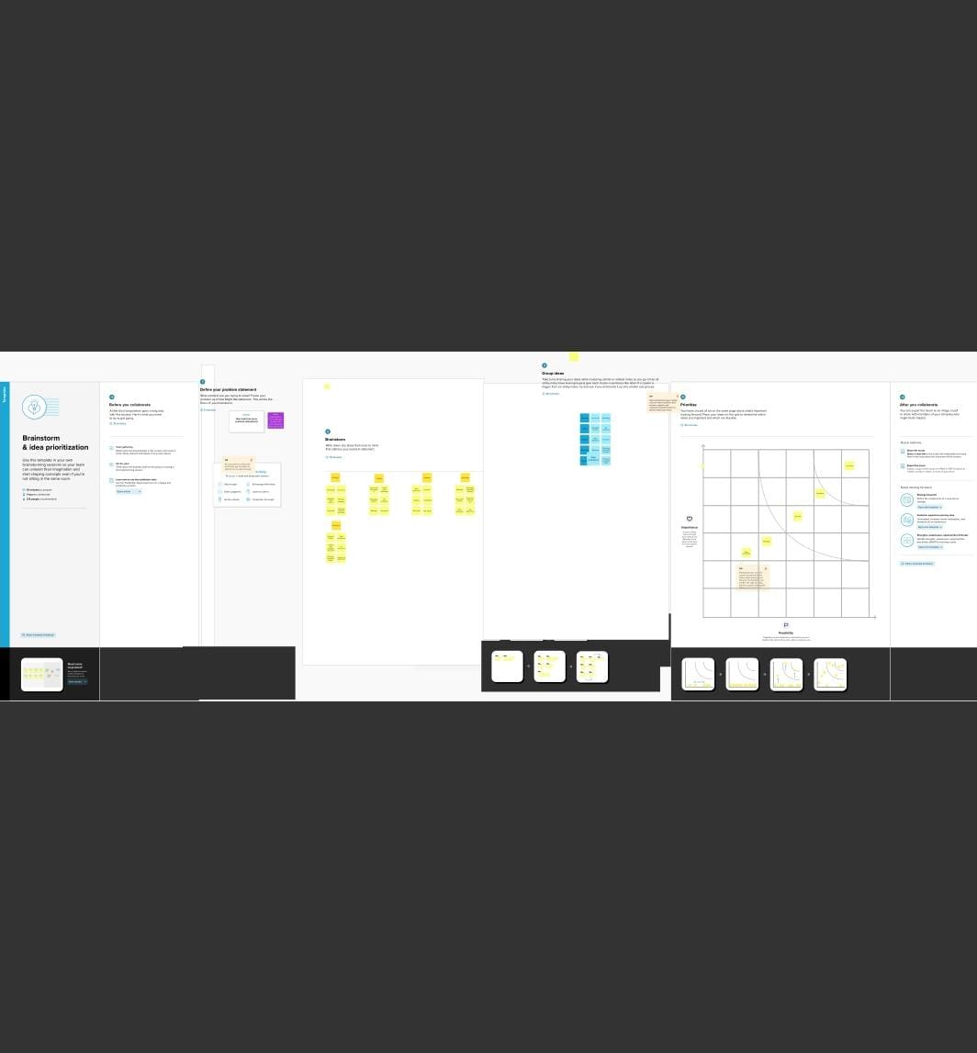

# RESULT

* 1. Data Model:

|  |  |
| --- | --- |
| Object Name | Field in the object |
| Events | |  |  | | --- | --- | | Field label | Data type | | City | Text | | Start date | Date/time | | End date | Date/time | |
| Attendees | |  |  | | --- | --- | | Field label | Data type | | Id | Auto number | | Phone | Phone | | Email | Email | | Tickets | Picklist | | Event Name | Master-detail Relationship | |
| Speakers | |  |  | | --- | --- | | Field label | Data type | | Bio | Text Area | | e-mail | Email | | Event Name | Look-up Relationship | |
| Vendors | |  |  | | --- | --- | | Field label | Data type | | e-mail | Email | | Phone | Phone | | Service Provider | Text | | Event Name | Look-up Relationship | |

# Milestone 1:

# C:\Users\user\Pictures\Screenshots\Screenshot (20).png

# Creation of Salesforce Account

# Milestone 2:

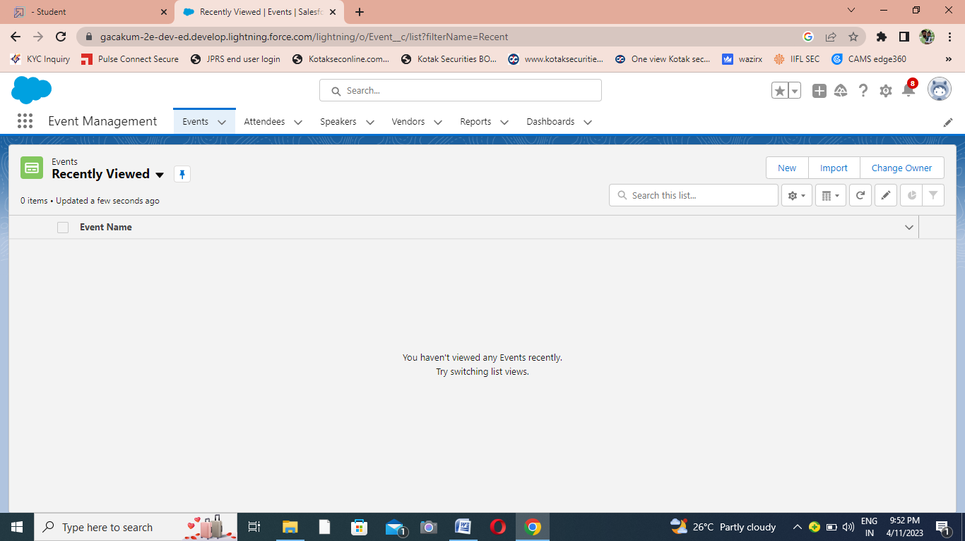

# Creation of Objects for Event Management

# Milestone 3:

# C:\Users\user\Pictures\Screenshots\Screenshot (10).png

# Creation of Event tab

# Milestone 4:

# C:\Users\user\Pictures\Screenshots\Screenshot (15).png

# Create the Event Management Construction app

# Milestone 5:

# C:\Users\user\Pictures\Screenshots\Screenshot (5).png

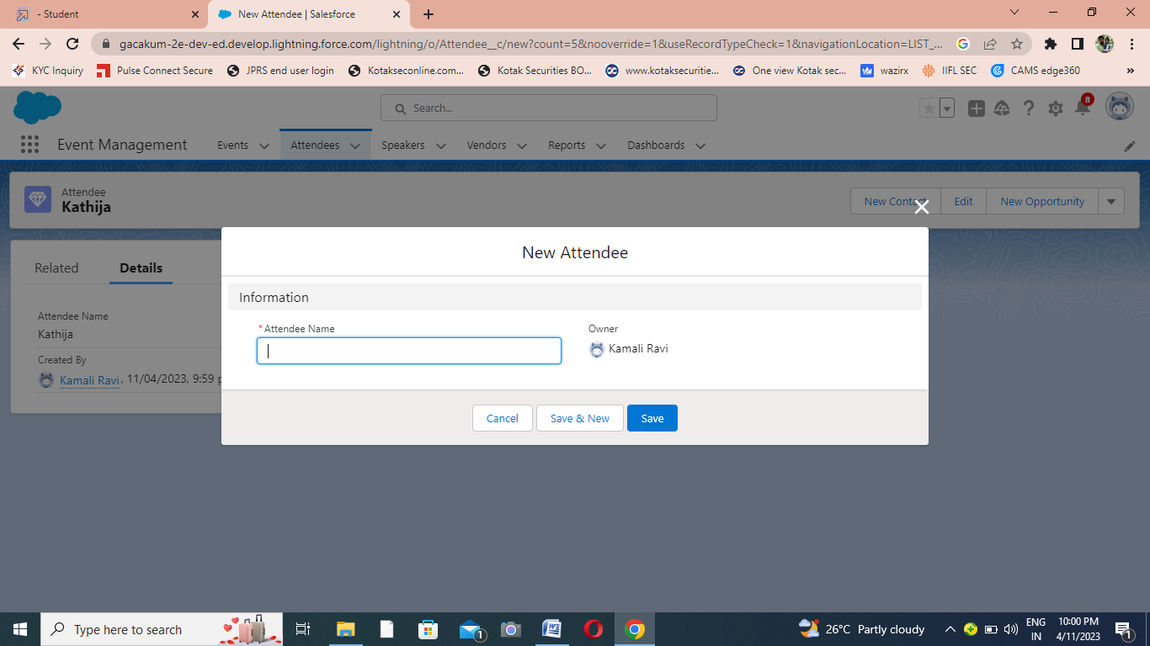

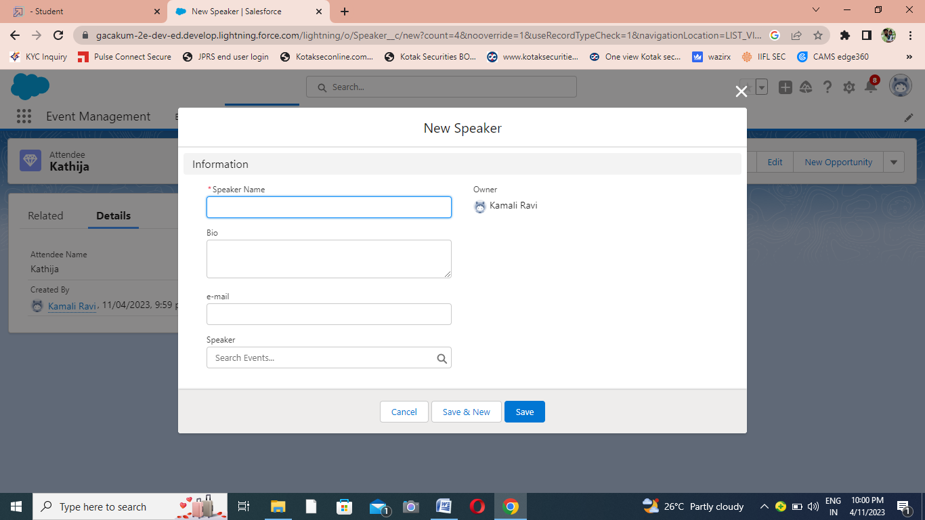

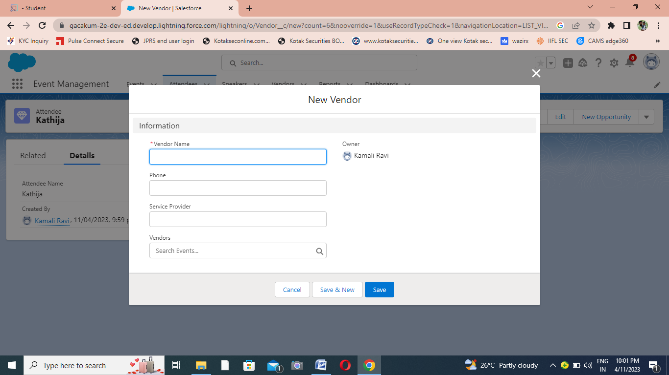

# Creation of Fields for the Event Management

# 

# Milestone 6:

# 

# UCreation on Profiles

# Milestone 7:

# C:\Users\user\Pictures\Screenshots\Screenshot (12).png

# Creating a User

# C:\Users\user\Pictures\Screenshots\Screenshot (13).pngMilestone 8:

## 

# Creating a Permission Set

# Milestone 9:

# C:\Users\user\Pictures\Screenshots\Screenshot (14).png

# Trailhead Pr

# Creating a Report

# 4 Trailhead public profile URL

**Team Leader - https://trailblazer.me/id/vsavithiri**

**Team Member 1- https://trailblazer.me/id/vmuthaiyan**

**Team Member 2 - https://trailblazer.me/id/vevel01**

**Team Member 3 ­-https://trailblazer.me/id/sthosh2**

**Team Member 4- https://trailblazer.me/id/uudhaya2**

**5 Advantages of Disadvantage**

**There are several advantages and disadvantages of using an Event Planner management service. These include: – Experience requirements, – Cost, – Loose coupling and – Stress. Experience is one of the most important factors. – Loose coupling is a disadvantage: a manager may not be aware of the costs and risks of the job.**

**6 Application**

* **The abililty to manage distributed audiences in a single platform.**
* **Local support with hardware for in-person events.**
* **Easy event registration & check-in(onsite & online)**

**7 Conclusion**

**Event Management System is user friendly and cost effective system, it is customized with activities related to event management life-cycle.**

It provides a new edge to management industry.

**8 Future Scope**

**In the 21st century each and every field is computerized and all works are done by using the modern technologies so it has a good future.**